We conducted 3 years span (2016-2019) of bid analysis and estimate, we found out large variance between estimate and design consultant estimate of each type of work. Especially in all type of libraries work. At end of report, we provide comments on current estimate process.

PB overall from 2016-2017:

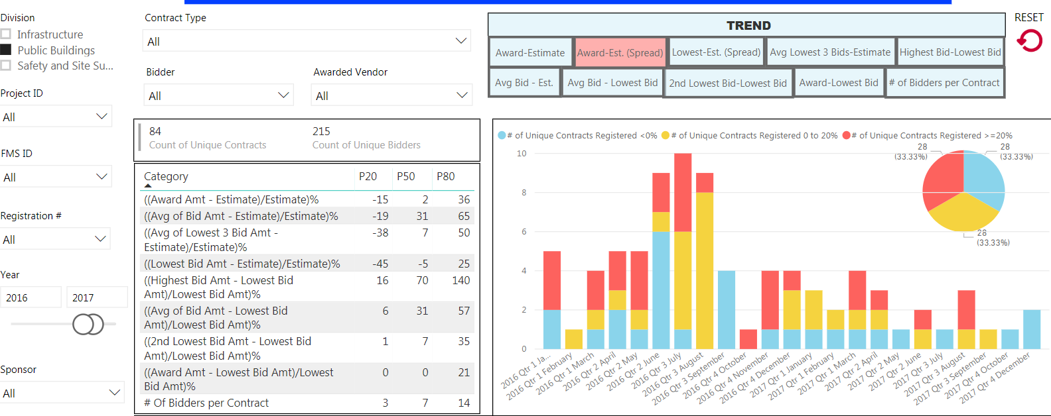

From year 2016 to 2017, large variance clusters in the month of February to the month of July.

PB overall for 2017-2018:

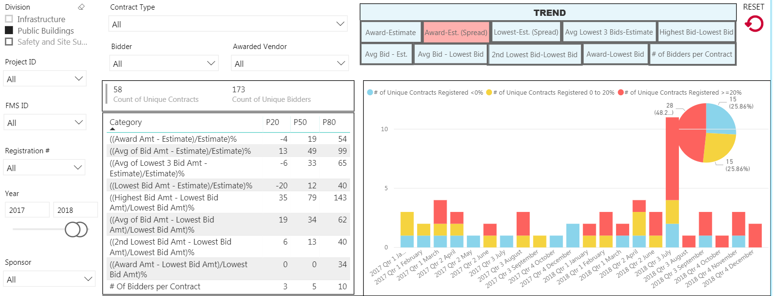

From year 2017 to 2018, large variance clusters in the month of February to the month of July.

PB overall 2018-2019:

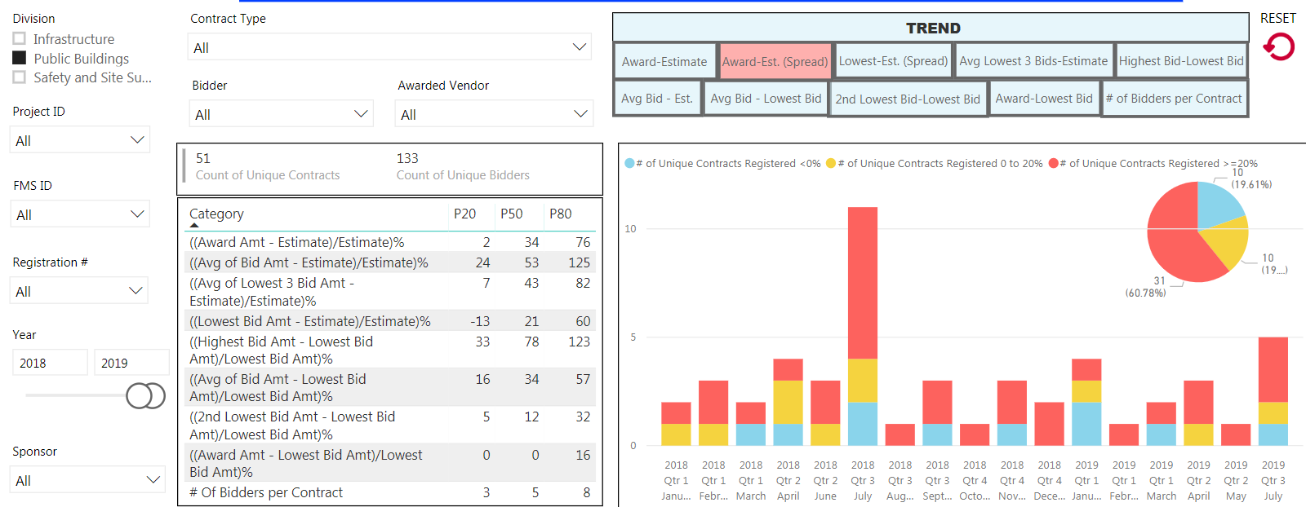

From year 2018-2019, majority of variance falls into month of February to month of July.

PB NYPL 2016 - 2019:

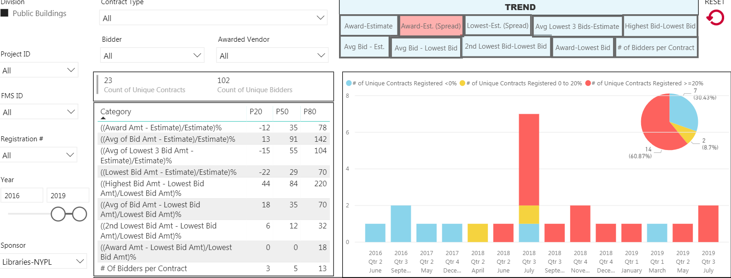

From year 2016-2019, there is a clear consistency in term of large variance starting from month of July 2018 to July 2019.

PB DCAS 2016 - 2019:

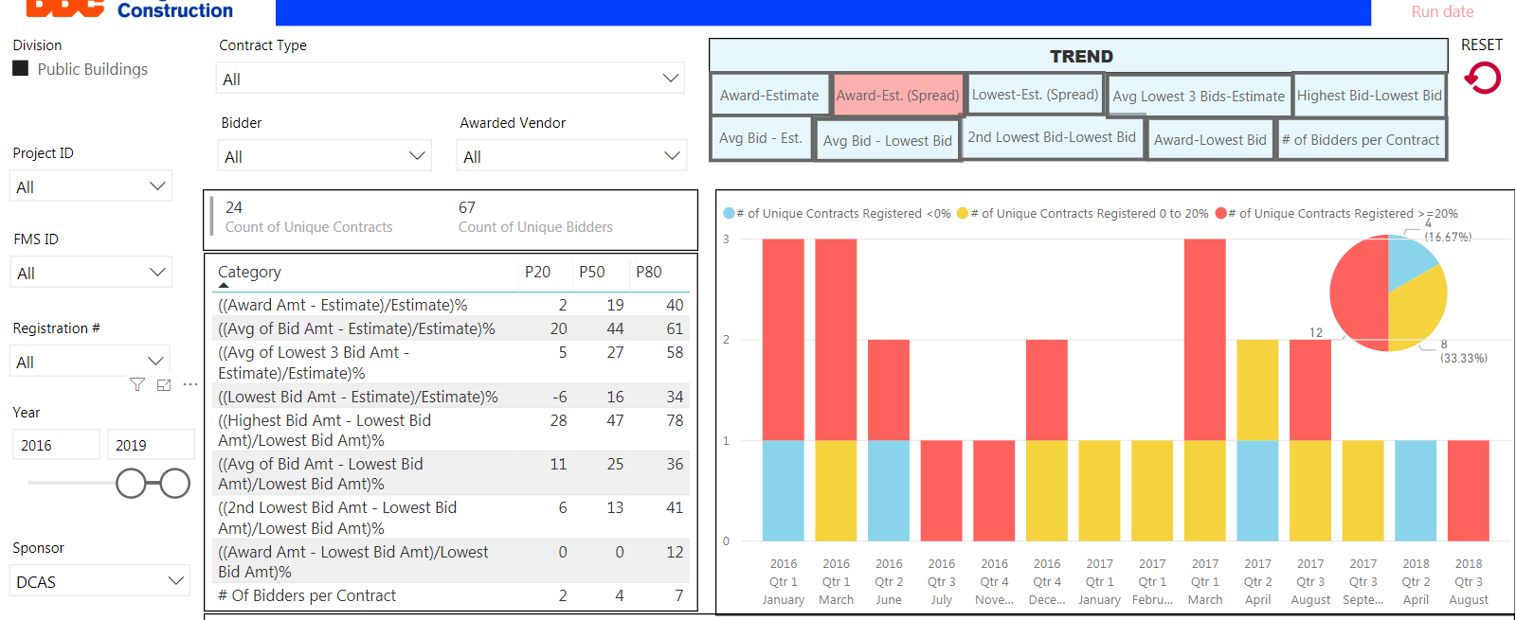

From 2016 and 2019, large variance cluster in February to July.

PB Homeless service 2016 - 2019:

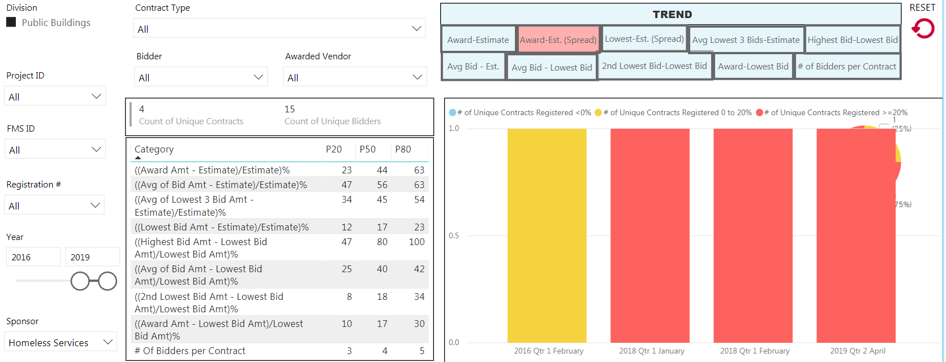

From 2016 and 2019, large variance cluster in February to April.

PB Parks & Recreation 2016-2019:

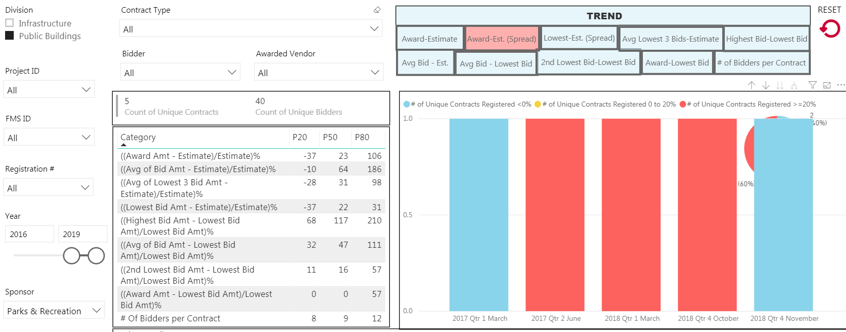

From 2016 and 2019, large variance cluster is all over.

PB Highest – lowest 2016- 2017:

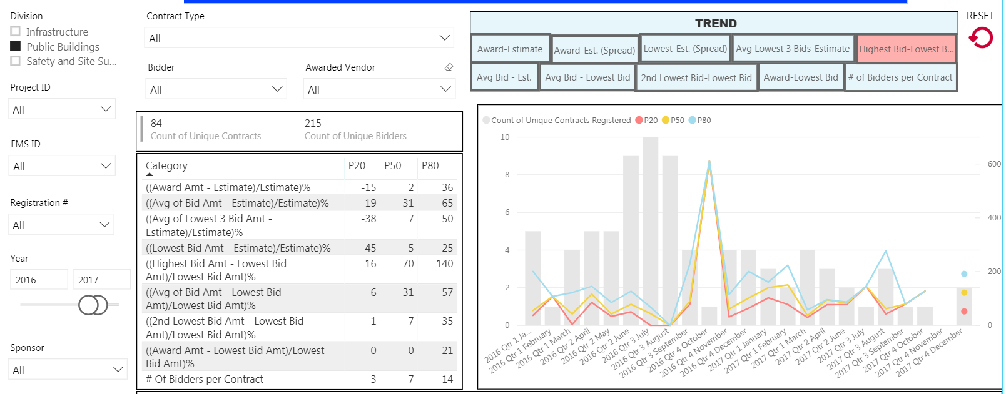

The largest variance is in October 2016, the smallest variance is in March 2016.

PB Highest – lowest 2017- 2018:

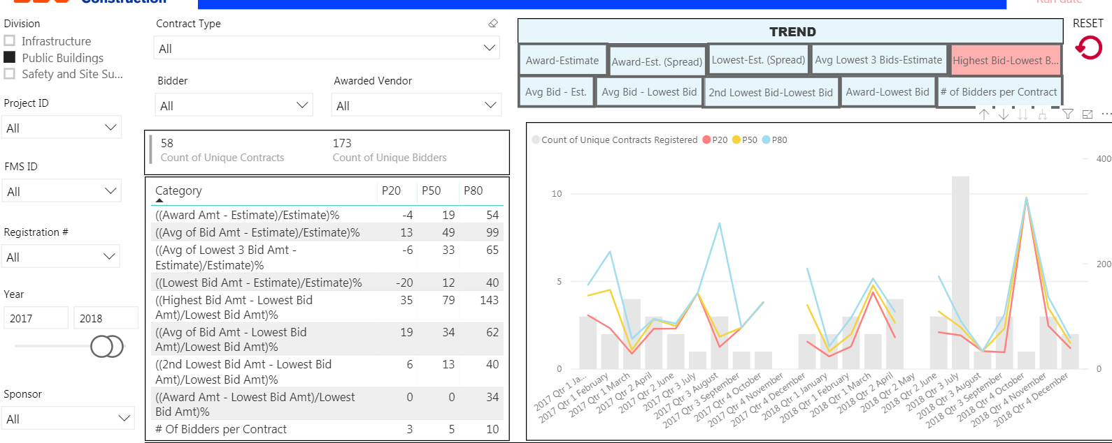

The largest variance is in October 2018, the smallest variance is in January 2017.

Bidders from 2018 to 2020:

* 10 out of 158 (6%) bidders who participate in more than 5 bids per year, they likely keep bidding.
* 116 out of 158 (73%) bidders who participate in bid last year, they are likely stop bidding next year.
* 37 out of 158 (21%) bidders actively participate in the bid last 3 years (2018-2020).
* November – January: DDC receives the most bidders and variance is within the range.
* February – April: small scale bidders participate in bid and variance start increasing to 15% above.
* May – July: large scale bidders participate in bid and variance increases to above 40%
* August – October: awarded bidders almost finish the job and come back for another bid, so the variance slightly drops.

Regular bid contract:

* 130 out of 319 (40%) award amount and estimate is more than 15%. (15% to 244%)
* 122 out of 319 (38%) are within the 15% range (-15% to 15%)
* 67 out of 319 (22%) are less than 15% (15% to -75%)

PQL bid contract:

* 21 out of 26 (80%) award amount and estimate is more than 15%. (18% to 141%)
* 4 out of 26 (15%) are within the 15% range (-1% to 12%)
* 1 out of 26 (5%) are less than 15% (-22%)

Consultant:

* DDC has total of 57 consultants prepared 345 contracts last three years.
* 5 major consultants control more than 9 projects, and remaining consultants control 2 contracts each.
* *Haks Engineering* and *Horizon Engineering* have least percentage variance in three categories.
* All other consultants have large variance in three categories.
* Average variance between design consultant and in-house estimate is 12%.

Overall comments in estimate:

* Spot review of design consultant estimate are not properly managed.
* Review the architect full estimate and prepare comments instead of spot revising.
* Develop the independent estimate or review full architect estimate.
* Instead of doing 10% on general condition, prepare estimate for each task as per contract duration.
* Sub-contractor overhead is not properly measure in the estimate.
* Market condition is not properly incorporated in each type of project.
* Manager should review every estimate and revise if necessary before the meeting with other parties.
* Program unit, architect, and estimating unit get to together and reconcile before bid.
* Revise estimate for each addendum and submit to program unit before opening the bid.
* Refresh estimate 6 months prior to the bid.
* Program unit should pick the latest estimate on the APT form.
* After each bid, share the estimating line items with responsive responsible bidder and prepare variances.
* Develop unit assembly estimate for future bid.
* Prepare quarterly bid variance reports for each type of projects and update to the database.
* Add proper escalation for PQL contracts.
* Standardized estimate template for design consultant and in-house estimate.
* Improve relationship between design consultant (in-house design) and PMs.
* From the recent 3 years analysis, we cannot fully depend on design consultant estimate.
* Establish shared folder for everyone within the unit, so everyone can access on it.